**Development of a demographic projection model for an endangered snake with limited monitoring data**

Anna M. Tucker, Conor P. McGowan, Nicole F. Angeli, Jan P. Zegarra… others?

**Target Journals:**

Global Ecology and Conservation

Herpetological Conservation and Biology

*This draft manuscript is distributed solely for purposes of scientific peer review. Its content is deliberative and pre-decisional, so it must not be disclosed or released. This manuscript does not represent any official USGS finding or policy.*

**ABSTRACT**

**INTRODUCTION**

For many rare and threatened species, little monitoring data exists to inform conservation decision-making (Karanth et al. 2003, Good et al. 2006, Brito 2010). In such situations, decision makers often rely on qualitative assessments of species risk which may be subjective and lack explicit acknowledge of uncertainty (McCarthy et al. 2004). Although qualitative methods are useful in many circumstances, there may be many cases where even some knowledge of the species life history and ecology can be used to develop demographic projection models that result in quantitative assessments of resiliency and extinction risk and associated uncertainties. These quantitative projections allow for the explicit acknowledgement and incorporation of uncertainty and provide decision makers with more nuanced results upon which to base their decisions.

Snakes are notoriously persecuted by humans worldwide and are a group of high conservation concern (Mullin and Seigel 2009, Böhm et al. 2013). A recent analysis of a randomly selected subset of reptile species showed that up to 33% of snake species worldwide may be threatened (Böhm et al. 2013). For many species there is data about species distribution only, and information about population trends is lacking. However, an analysis of 17 snake populations in Europe, Australia, and Nigeria found that 11 (65%) declined sharply over the ~20 year study period (Reading et al. 2010). Habitat loss due to urbanization and human development is one of the main threats facing snake populations (Gibbons et al. 2000, Böhm et al. 2013). Additionally, as humans move into previously natural areas snakes face increased threats as result of human interactions (Burghardt et al. 2009).

Snakes and many other reptiles are difficult to monitor, leading to data deficiency for many species (Böhm et al. 2013). Many snakes are cryptic and difficult to detect, exhibit low activity, and are not commonly captured using standardized sampling protocols (Winne et al. 2007). As a result, quantitative assessments of perceived declines are lacking (Bland and Böhm 2016). Lack of monitoring data also makes it difficult to quantify relationships between environmental stressors and population dynamics (Gibbons et al. 2000). This makes conservation planning and assessment difficult.

The Puerto Rican boa (*Chilabothrus inornatus*) is a terrestrial boa endemic to the island of Puerto Rico. This species has been classified as Endangered in the United States since 1970 and its status was recently reviewed. Species Status Assessments (SSAs) are science documents developed by United States Fish and Wildlife Service biologists to support decisions under the Endangered Species Act (Smith et al. 2018). SSAs require an assessment of how the species is likely to respond to future threats, which is used to determine whether protection under the ESA is warranted. Despite widespread accounts of species occurrence, there are no estimates of historic or current population size and limited field studies. However, demographics and life history of captive populations are well understood. We used expert opinion and published studies to develop a demographic projection model, which was used to assess the predicted future status of the Puerto Rican boa (hereafter, PR boa) under several potential scenarios. This model allowed us to incorporate many sources of uncertainty to produce quantitative estimates of quasi-extinction risk and population growth.

**METHODS**

*Focal Species*

The Puerto Rican boa is a large boa that grow to an average size of ~5 ft and live up to 32 years. Females reproduce biennially, producing 18-32 eggs per clutch (Huff 1978, Tolson 1992, Puente Rolon 2012). After hatching, young reach sexual maturity at around 5 years (Huff 1978). Diet and behavior vary across life stage, with smaller boas remaining in trees and shrubs to forage on small lizards and frogs, gradually moving to the ground as they grow and begin to also consume rodents, birds, and bats. Small boas may be predated by mongoose, cats, and some birds, but the main sources of larger boa mortality are road strikes and human persecution.

*Expert Meeting*

On March 5-6, 2018, a team of species experts met to develop a modeling framework that would inform an upcoming SSA. During that meeting the team developed a life cycle model (Figure 1), identified key threats, and estimated demographic rates by consensus. Experts agreed that the PR boa status should be assessed as a single analysis unit comprising the island of Puerto Rico, noting homogeneity in genetics, morphology, and behavior across the island.

*Demographic Matrix Model*

We developed a stage-based Lefkovitch matrix model (Caswell 2001) for this population that grouped individuals into stages based on size (Figure 1). We considered four life stages: young (<60 cm), juveniles (60-90 cm), subadults (90-110 cm), and adults (>110 cm). We elicited the probabilities of annual survival, growth to the next size class, and fecundity (average number of offspring per individual) for each size class from the expert team or, where applicable, drew from the available literature (Table 1). The experts used personal information, unpublished data, and inference from captive zoo populations to determine average productivity, survival, and growth rates. The experts also directed us to graduate theses and dissertations that were completed but not widely available through literature searches.

**Figure 1**. Life cycle and stage-based matrix model for the Puerto Rican boa.

**Table 1**. Stage-specific demographic rates. Average values were determined by the expert team or drawn from available literature. Standard deviations (SD) were calculated assuming that rates varied within 15% of the average.

|  |  |  |  |  |
| --- | --- | --- | --- | --- |
| **Demographic rate** | **Description** | **Average** | **SD** | **Rationale** |
|  | Survival – Young | 0.3 | 0.045 | Expert opinion, informed by studies of Cuban boaa |
|  | Survival – Juvenile | 0.9 | 0.135 | Expert opinion |
|  | Survival – Subadult | 0.72 | 0.108 | Expert opinion – survival of this stage is lower than the juvenile or adult stage because individuals begin dispersing widely and face more threats |
|  | Survival – Adult | 0.9 | 0.135 | Expert opinion and estimates from radio-tracked translocated snakesc |
|  | Growth – Young to Juvenile | 0.67 | 0.101 | Expert opinion – approximately 2/3 of the young of the year grow enough to become juveniles in the next year. |
|  | Growth – Juvenile to Subadult | 0.5 | 0.075 | Expert opinion – juvenile stage typically lasts two years |
|  | Growth – Subadult to Adult | 0.25 | 0.375 | Expert opinion – subadult stage typically lasts four years |
|  | Fecundity – Adult | 4.5 | 1.35 | Average clutch size is 18 (range = 12-32)b,c This clutch size is multiplied by 0.5 because only females produce young (assumes a 50:50 sex ratio) and multiplied by 0.5 again because females reproduce bienniallyd |
|  | Fecundity – Subadult | 2 | 1.35 | Expert opinion – some larger subadults may breed, but with a lower breeding probability |

aP. Tolson pers. comm.

bTolson 1992

cPuente-Rolon 2012

dHuff 1978

We used the stage-specific estimates of survival and growth to calculate the transition rates in the diagram and matrix in Figure 1. These demographic rates are summarized in a matrix:

*Habitat Availability*

The Puerto Rico GAP Analysis (Gould et al. 2008) developed habitat suitability models for a suite of species. That analysis estimated a total of 414,379 ha of suitable habitat for the PR boa. However, per USFWS recommendation, there are no clear records of PR boa above 700 m, so we only considered areas below 700 m to be suitable habitat, resulting in 379,029 ha of habitat. We were also interested in determining the proportion of habitat that fell in developed, urban areas, as experts believed boas experience different pressures in those areas (see *Differences Between Natural and Urban Habitat*, below). We used a raster dataset developed by Martinuzzi et al. (2007) to determine the proportion of suitable habitat falling within developed areas (Figure 2). Martinuzzi et al. (2007) used remote sensing data and information from the U.S. Census Bureau to define three land use types across Puerto Rico: urban, densely-populated rural, and sparsely-populated rural. Human persecution is a key threat to this species, so we considered habitat within sparsely populated areas to be “natural”, i.e. minimally disturbed, and habitat within either urban or densely populated areas to be “developed”. Of the estimated 379,029 ha of suitable habitat, 43% falls within developed areas (Figure 2).

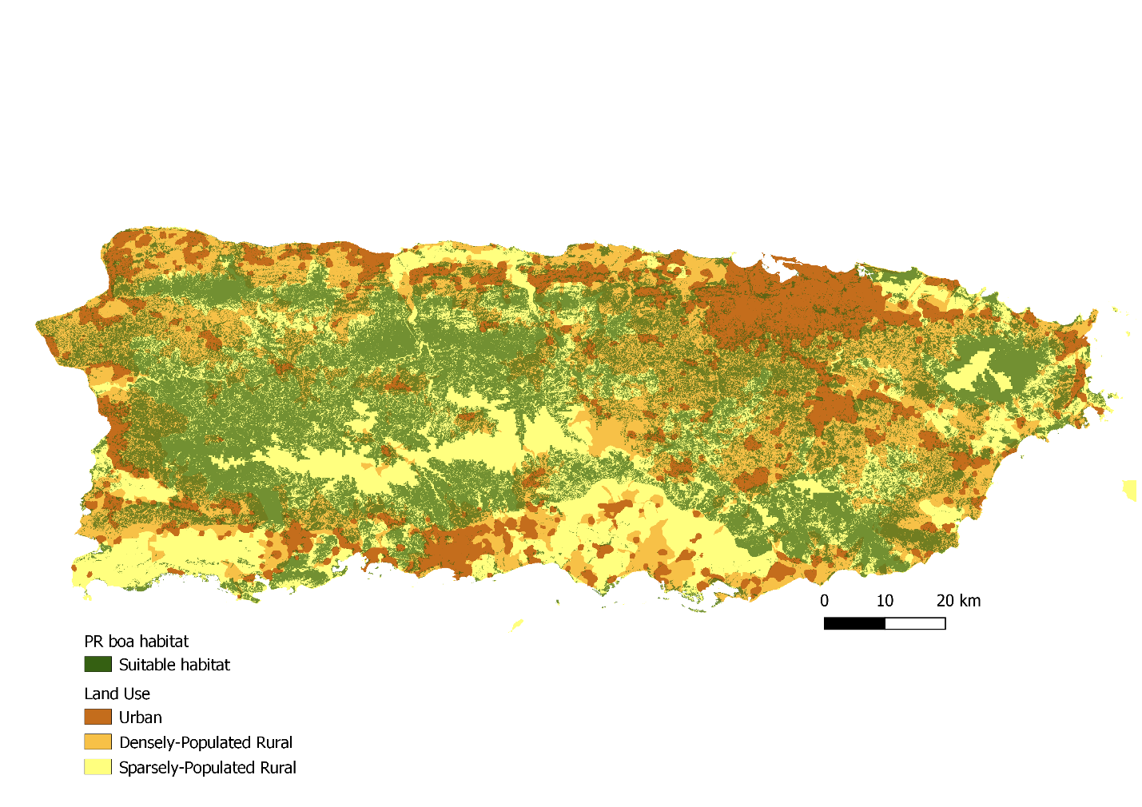

**Figure 2.** Habitat availability for Puerto Rican boas. Suitable habitat (green) was based on the PR Gap Analysis and only includes pixels at less than 700 m elevation. Land use raster based on remote sensing and U.S. Census Bureau data was used to determine the proportion of habitat falling within developed (urban and densely-population rural) versus natural (sparsely-populated rural) areas.

*Carrying Capacity*

We imposed density dependence on this population in the form of a simple population ceiling. Published estimates of PR boa density range from 1-6 boas/ha (Mulero-Oliveras 2019). If all available habitat was used (379,029 ha), this corresponds to a maximum population size ranging from 379,029 to 1,137,087 individuals. Although some studies have estimated higher boa densities in some areas (6-7 boas/ha), all available estimates are from the northern part of the range where habitat is higher quality and densities are likely greater than in the southwest. To account for variation in density and habitat quality across the island, we chose to set the maximum island-wide density at 3 boas/ha. We compared model outputs for simulations with varying maximum densities and found that these input values had little to no effect on resulting probabilities of population growth or quasi-extinction (Appendix B).

For each model replication, we randomly drew a carrying capacity from a Uniform distribution bounded by this minimum and maximum. We assumed that reproduction would cease if the ceiling was reached, and therefore imposed a rule that set fecundity equal to zero if the total population size reached the ceiling. This approach is a simplified model of how carrying capacity would affect population demographics. It is likely that approaching and exceeding carrying capacity would affect multiple demographic processes, but we do not have data to estimate these effects and so implementing a simple fecundity reduction ceiling function allows us to limit population growth without speculating on the functional form of density dependence (Morris and Doak 2002, McGowan et al. 2017).

*Initial Population Size*

The current population size of PR boas is unknown, and little data exists to inform estimates of current abundance. Therefore, for each model replication, we randomly drew an initial population size from a predetermined range. The range for possible current abundance was estimated using published estimates of boa density and input from the expert team, and we assumed a range of 0.1 to 0.5 boas/ha across all available habitat as a starting density, which corresponds to a range of 37,903 to 189,515 boas in the current population. We chose a maximum current density lower than that estimated by published studies from the north (up to 7 boas/ha) to account for the fact that densities are likely lower in other parts of the range. The final population size depends in part on the initial population size, so we present projection results as the change in population size from the first year.

*Uncertainty in Demographic Rates*

At the expert meeting described above the team approximated the average value of each rate, but we did not conduct a formal elicitation to obtain estimates of uncertainty in those estimates (Burgman 2005). To incorporate uncertainty in our estimates of the average demographic rates, we assumed that the error in our mean estimate was 15% of the average value approximated by the team. For example, the team estimated average adult survival probability as 0.9, so we assumed a standard deviation of . For each transition probability, we randomly drew an average value for each iteration from a Beta distribution, using the method-of-moments method to calculate the shape parameters. For the fecundity rates, we randomly drew an average value from a Log-normal distribution.

*Temporal Variation in Demographic Rates*

Realized demographic rates often vary annually based on stochastic variation in environmental conditions. To allow for temporal variation in realized rates, we assumed the standard deviation in realized annual rates was 15% of the mean. We used these replication-specific mean and standard deviation to define the distributions from which annual rates were drawn. Transition probabilities were drawn from a Beta distribution and fecundity rates were drawn from a Log-normal distribution.

*Differences Between Natural and Urban Habitat*

PR boas occur in many different habitats across the island and experience different conditions in each habitat type. For this projection, we assumed that boas could occupy either natural or urban (developed) habitat. Natural habitat was defined as all suitable habitat falling within sparsely-population areas and urban habitat was defined as all suitable habitat within densely-population or urban areas, as defined by Martinuzzi et al. (2007). Experts believed that in more developed areas boas experience higher mortality due to human persecution, road strikes, and the occurrence of feral cats. Therefore, we assumed that all realized demographic rates would be lower in urban habitats than in natural (undeveloped) conditions. There was some uncertainty in the magnitude of this effect, so we allowed it to vary among replications. For each replication we calculated average rates in urban habitats as the average baseline rate multiplied by a randomly drawn habitat effect with a minimum of 0.5 and a maximum of 1. This allowed the demographic rates in urban areas to be lower than those in natural settings by up to 50%.

*Sensitivity Analysis*

Most of the demographic rates used in this model have not been empirically estimated for this population, therefore we relied on approximation by the expert team. To evaluate the sensitivity of model outputs to these input values, we ran simulations in which we randomly drew values for survival and fecundity from a wide range of possible values. For survival rates, we drew values between 0.01 and 0.99, and for fecundity we drew values between 1 and 20. For each demographic rate we randomly drew 1000 values, holding all other rates constant at the average values in Table 1. We simulated 1000 replications of the population projection at each value, keeping the initial population size and carrying capacity fixed at 215,000 and 1,000,000, respectively. For each projection we determined whether the population remained stable or grew by determining whether the population size in the final year was greater than or equal to the initial population size. We also calculated the probability of quasi-extinction at the most conservative threshold (5000 individuals) by finding the proportion of replicates in which the population size fell below 5000.

We also evaluated the sensitivity of model outputs to the input ranges of possible current abundance and carrying capacity. We compared four different iterations of the simulation model that set the upper bound for current density at either 1 boa/ha or 0.5 boa/ha and set the upper bound for carrying capacity at either 6 boas/ha or 3 boas/ha. We projected the population for 1000 replicates per scenario and compared the probabilities of population growth, decline, and quasi-extinction.

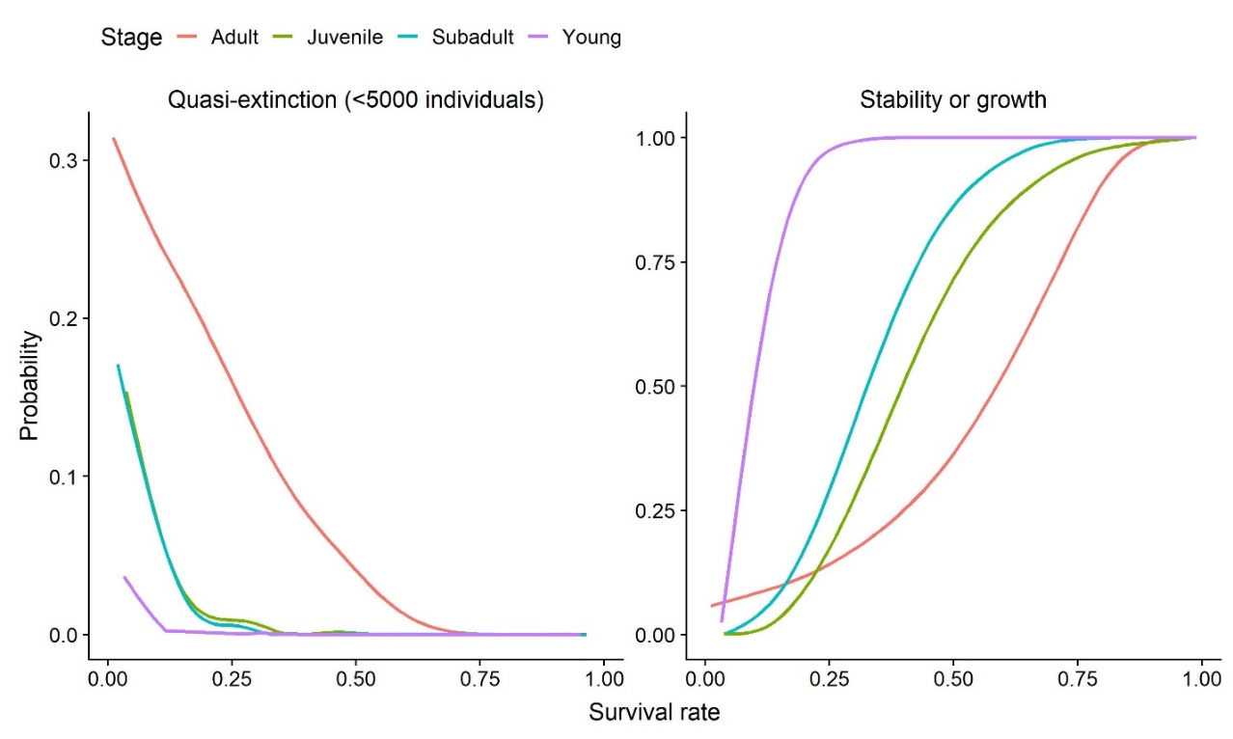

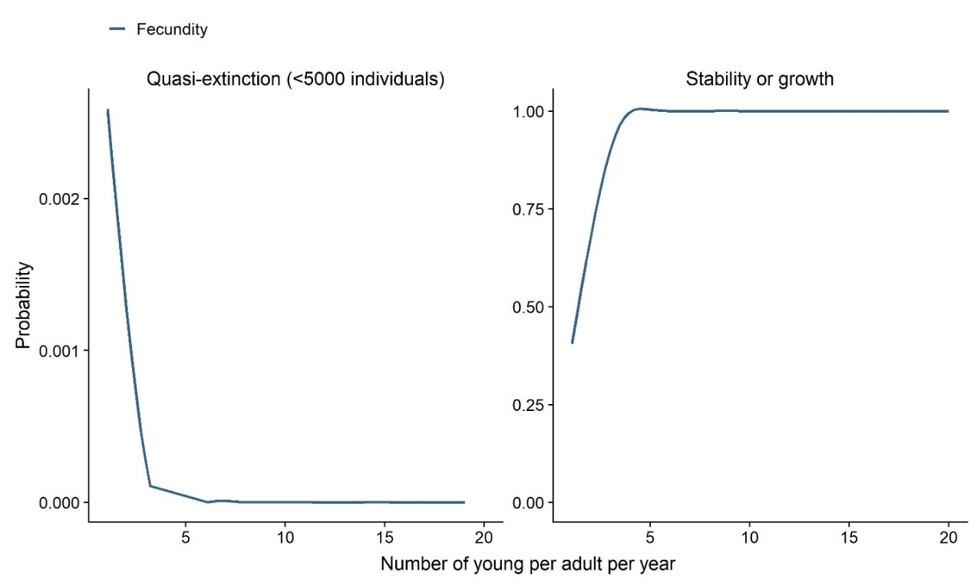

**Figure X.** Simulated probabilities of quasi-extinction and of population growth over the range of possible survival rates (A) for each stage (adult – orange, subadult – blue, juvenile – green, young – purple) and fecundity (B).

*Future Scenarios*

The key threats to this species are habitat loss and human interactions, both of which are linked to increased development and conversion of natural areas into urban areas. PR boas can persist in islands of habitat within an urbanized matrix (Mulero-Oliveras 2019), but not in a purely developed landscape. We considered future scenarios that included changes in land cover such that developed areas would encroach upon natural areas, resulting in both an increased proximity of natural areas to development and loss of overall habitat area. Each scenario had a different urbanization rate, which was implemented as the rate at which both overall suitable habitat area declined and the rate at which the percent of available habitat falling within developed areas increased (Figure 3). By simulating simultaneous habitat loss and land cover change, these scenarios represent the most extreme way that urbanization could impact PR boa populations. A recent analysis of past rates of urbanization in proximity to protected natural areas in Puerto Rico (Castro-Prieto et al. 2017) found that urban growth increased at a rate of 16% over 2000-2010. For a best-case scenario, we assumed no future urban growth (0% per decade), and therefore that the percent of habitat within developed areas would remain the same as current conditions (43%) and that the total amount of habitat would remain constant (379,029 ha). We next considered a scenario in which the rate of urbanization was reduced by half to a rate of 8% per decade, and therefore that both the proportion of habitat falling in an urban matrix would increase by 8% every ten years and the total habitat area would decrease by 8% every ten years. For a status quo scenario, we assumed the rate of urbanization would continue at 16% per decade, and the total amount of available habitat would decrease by 16% every ten years. For the worst-case scenario, we assumed that the rate of urbanization would increase by half to rate of 24% per decade. To implement these changes in land cover in the model, we calculated the expected rate of development per year and used this to calculate the predicted total habitat availability and proportion in urban areas. This assumes that development occurs gradually each year (Figure 3).

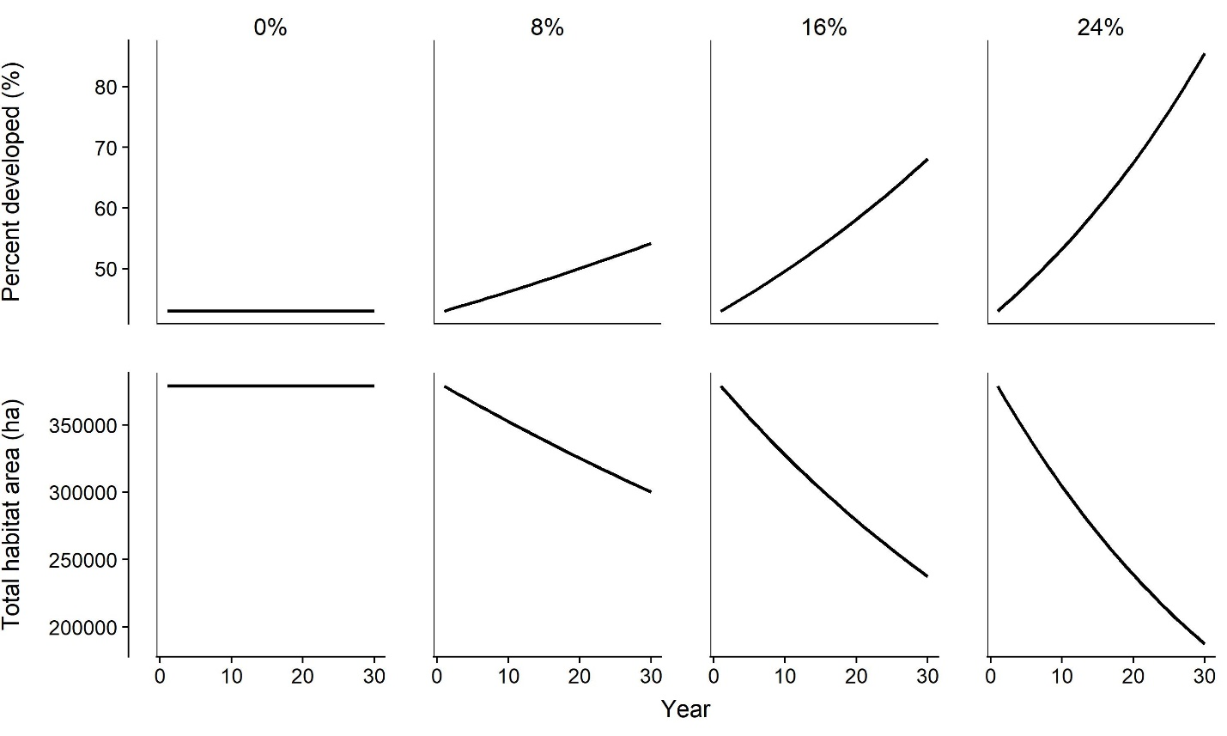

**Figure 3**. Change in the total habitat area and the proportion of habitat falling within an urban area under four future scenarios, each representing a different rate of urbanization (0% per decade, 8% per decade, 16% per decade, or 24% per decade). These scenarios are based on an analysis by Castro-Prieto et al (2017) and described in text.

**Table 4.** The total habitat area and proportion of habitat falling within an urban area in 30 years under four potential rates of urban growth.

|  |  |  |  |
| --- | --- | --- | --- |
| Scenario | Urban growth per decade | Total habitat area in final year (ha) | Percent of habitat in developed areas in final year |
|
| No further urbanization | 0% | 379,029 | 43% |
| Reduced urbanization | 8% | 300,269 | 54% |
| Status quo | 16% | 237,427 | 58% |
| Increased urbanization | 24% | 187,377 | 86% |

*Population Projection*

We projected the population for 100,000 replications per scenario. For each replicate, we randomly drew the initial population size, carrying capacity, and average demographic rates. The initial population size in each habitat type was equal to the iteration initial population size multiplied by proportion of the available habitat in that type. We projected each population for 30 years, starting in the stable stage distribution as calculated from the replication average matrix using the popbio package for R (Stubben and Milligan 2007, R Core Team 2016). For each year, we calculated annual realized demographic rates as described above and calculated the population size by multiplying the year-specific matrix by the population size in the previous time step. We summed the number of individuals in each stage to determine the total population size and calculated the change in population size from the first year by subtracting the initial population size from the projection population size. We calculated the average population growth rate (λ) for each replicate by finding the geometric mean of the year-specific growth rates . We calculated the probabilities of population growth and decline for each scenario as the proportion of replicates in which the average population growth rate was greater than or equal to 1 or less than 1, respectively.

*Quasi-extinction Threshold*

The quasi-extinction threshold is the population size below which either the population cannot recover because it enters an “extinction vortex” (Gilpin and Soulé 1986), or the plausible management alternatives would drastically change (e.g., switching from habitat management to captive breeding). Selecting an appropriate quasi-extinction threshold for a specific population is often challenging due to uncertainties about how demographic feedbacks and management actions influence realized population dynamics. Therefore, we assessed quasi-extinction risk at four thresholds: total population size of 50, 500, 1000, or 5000. For each scenario, we calculated the probability of the population falling below these thresholds as the proportion of replicates in which this occurred.

**Figure 4.** Conceptual diagram of the stochastic simulation model used to assess the future condition of PR boas under different rates of urbanization. White hexagons on the left represent model inputs and gray hexagons on the right represent model outputs. Rectangles represent values calculated within each replication of the simulation.

**RESULTS**

*Sensitivity Analysis*

Changes in adult survival probability had the strongest influence on both the probability of quasi-extinction and of population growth (Figure A1). Quasi-extinction probability was ~0 for all iterations in which adult survival was > 0.75. This analysis also indicated some thresholds at which we expect population dynamics to change. For example, the probability of population growth declined drastically as fecundity fell below ~4 young per adult per year (Figure A2). We note that this sensitivity analysis is conducted assuming that only one demographic rate changes independent of the others, while, in reality, threats likely influence more than one rate simultaneously.

Changing the input for maximum current density and maximum carrying capacity density had little effect on simulation model outcomes (Figure A3). Reducing the upper bound for initial population size (current density) resulted in slightly higher quasi-extinction probabilities, but probability of quasi-extinction was ~1% at the highest threshold and under the worst urbanization scenario. Reducing the upper bound for carrying capacity resulted in slightly lower probabilities of population growth and lower probabilities of population decline.

*Population Projection*

Our projection model indicated that the population is most likely to decline over a 30-year period under the status quo scenario, i.e. if the current rate of urbanization were to continue (Table 4, Figure 5). Under the current rate of urbanization (16% per decade) the model predicted a 54% probability of decline and 46% probability of stability or growth. Lower rates of urbanization were associated with a greater probability of population stability or growth, but the probability of growth was only 56% under the best case scenario (no further urbanization), which may be unlikely to occur. However, quasi-extinction probability was low, likely due to the possibility of a large current population size (initial population size range from 37,903 to 189,515 individuals, see *Initial Population Size* above), and was less than 5% for all scenarios and thresholds (Table 5, Figure 6).

**Table 5.** The probabilities of quasi-extinction, population growth, and population decrease for each scenario. We evaluated quasi-extinction probability at four thresholds due to our uncertainties about how that threshold should be determined. The probability of population growth and decline are the proportion of replicates in which the average population growth rate (λ) was greater than 1 or less than 1, respectively. Average population growth rate and percent change in population size are presented as the median and 95% quantiles among all replicates.

|  |  |  |  |  |  |  |  |  |
| --- | --- | --- | --- | --- | --- | --- | --- | --- |
| Urban growth | Quasi-extinction probability | | | | Probability of population stability or growth | Probability of population  decline | Average population growth rate (λ) | Percent change from year 1 |
| 50 | 500 | 1000 | 5000 |
| 0% | 0 | 0.00009 | 0.0007 | 0.018 | 0.52 | 0.48 | 1.0  (0.91, 1.09) | 6.6  (-93.3, 1127) |
| 8% | 0 | 0.0001 | 0.0009 | 0.025 | 0.47 | 0.53 | 0.99  (0.91, 1.08) | -11.7  (-94.5, 891) |
| 16% | 0 | 0.0003 | 0.0016 | 0.035 | 0.42 | 0.58 | 0.99  (0.90, 1.07) | -26.6  (-95.5, 706) |
| 24% | 0 | 0.0004 | 0.0022 | 0.046 | 0.37 | 0.63 | 0.98  (0.89, 1.07) | -39.8  (-96.2, 535) |

**Figure 5.** Projected change in population size over 30 years for four potential scenarios of land cover change. Solid black lines show the medians among all replicates, and shaded gray regions show the 95% quantiles (95% of replications fell within this range). The dashed line is at 0, indicating no change in population size.

**Figure 6.** Predicted quasi-extinction probability for the PR boa under four scenarios of future urbanization, evaluated at four different quasi-extinction thresholds (50, 500, 1000, and 5000).

**DISCUSSION**

We developed a demographic projection model for the PR boa that incorporated many sources of uncertainty regarding current population status and population vital rates, despite lack of monitoring data to inform past or current abundance. Using this model, we simulated population dynamics over 30 years under four scenarios of future urbanization and found that there was nearly an equal probability of population growth or decline under all scenarios. The probability that the population would remain stable or grow was greater than 50% only when urbanization rates fell below the current rate (16% per decade). Increasing rates of urbanization were associated with an increased quasi-extinction probability only at the highest threshold (5000 individuals). Quasi-extinction probabilities were low for most scenarios due to the possibility of a large initial population size, which buffers the population from falling below the quasi-extinction thresholds within 30 years. If the true current population size is lower than our projected minimum of 37,903 individuals, quasi-extinction probability may be greater.

This model is largely built based on the personal knowledge and opinion of species experts, with support from some published studies. The sensitivity analyses serve to evaluate the effect of key model inputs on our estimates of the probability of quasi-extinction or population growth. Methods exist to formally elicit demographic parameter estimates and relationships from experts, but those are also time- consuming and can be expensive, or not feasible if few people are experts on the species biology (Martin et al. 2012, Drescher et al. 2013, Burgman 2016). Such methods are very useful especially for eliciting estimates of uncertainty in demographic rates, i.e. variance or 95% CI. Here, we applied a blanket uncertainty of 15% to all demographic rates because we did not have expert elicitation results, but our projection would be improved by including explicit estimates of uncertainty for each demographic rate. With or without those expert-elicited estimates of parametric uncertainty, a sensitivity analysis like the one presented here can help identify which demographic rates contribute the most to realized population trajectories, and can provide decision makers with target thresholds (e.g., adult survival > 0.75) that may be useful in recovery planning.

Without demographic information, occupancy models can be useful for predicting species presence across its range. However, occupancy alone may not be sufficient to understand responses to future threats because animals often exist in suboptimal habitat (Schlaepfer et al. 2002, Battin 2004). For the PR boa, there are opportunistic sightings from across the range, most frequently in human-dominated areas. That alone might indicate that urbanized habitat is suitable for boas, but species experts agreed that those areas are likely population sinks in which boas experience increased mortality due to road strikes and direct human persecution. By modeling the proportion of habitat in urbanized areas and allowing for a large range in the negative effect of urbanization, we were able to capture this nuance and build scenarios focused on future urbanization in Puerto Rico.

Density dependence presents a challenge in developing demographic projections because the mechanisms and functional form of population responses to increased density are still poorly understood for many species. Especially for an island endemic, we thought it important to restrict population growth but had no data to inform carrying capacity or population responses to increased density. By using published estimates of boa density and home range size, we calculated a reasonable range of possible carrying capacities for the island of Puerto Rico. We imposed density dependence in the projection using a simple ceiling function, though in reality population response to density is likely more complex and nuanced. Future work on the functional forms of density dependence and best practices for including density dependence in population projections is needed.

This analysis synthesized information from the published and grey literature with expert opinion to develop a quantitative projection model despite many uncertainties about current population status and demographic rates. Because we explicitly incorporated those uncertainties in the simulation model, the outputs reflect our best predictions given those uncertainties. Even when data are sparse, quantitative methods can often be used to produce rigorous and reproducible estimates of future status with quantifiable uncertainty.

**LITERATURE CITED**

Battin, J. 2004. When Good Animals Love Bad Habitats: Ecological Traps and the Conservation of Animal Populations. Conservation Biology 18:1482–1491.

Bland, L. M., and M. Böhm. 2016. Overcoming data deficiency in reptiles. Biological Conservation 204:16–22.

Böhm, M., B. Collen, J. E. M. Baillie, P. Bowles, J. Chanson, N. Cox, G. Hammerson, M. Hoffmann, S. R. Livingstone, M. Ram, A. G. J. Rhodin, S. N. Stuart, P. P. van Dijk, B. E. Young, L. E. Afuang, A. Aghasyan, A. García, C. Aguilar, R. Ajtic, F. Akarsu, L. R. V. Alencar, A. Allison, N. Ananjeva, S. Anderson, C. Andrén, D. Ariano-Sánchez, J. C. Arredondo, M. Auliya, C. C. Austin, A. Avci, P. J. Baker, A. F. Barreto-Lima, C. L. Barrio-Amorós, D. Basu, M. F. Bates, A. Batistella, A. Bauer, D. Bennett, W. Böhme, D. Broadley, R. Brown, J. Burgess, A. Captain, S. Carreira, M. del R. Castañeda, F. Castro, A. Catenazzi, J. R. Cedeño-Vázquez, D. G. Chapple, M. Cheylan, D. F. Cisneros-Heredia, D. Cogalniceanu, H. Cogger, C. Corti, G. C. Costa, P. J. Couper, T. Courtney, J. Crnobrnja-Isailovic, P. A. Crochet, B. Crother, F. Cruz, J. C. Daltry, R. J. R. Daniels, I. Das, A. de Silva, A. C. Diesmos, L. Dirksen, T. M. Doan, C. K. Dodd, J. S. Doody, M. E. Dorcas, J. Duarte de Barros Filho, V. T. Egan, E. H. El Mouden, D. Embert, R. E. Espinoza, A. Fallabrino, X. Feng, Z. J. Feng, L. Fitzgerald, O. Flores-Villela, F. G. R. França, D. Frost, H. Gadsden, T. Gamble, S. R. Ganesh, M. A. Garcia, J. E. García-Pérez, J. Gatus, M. Gaulke, P. Geniez, A. Georges, J. Gerlach, S. Goldberg, J. C. T. Gonzalez, D. J. Gower, T. Grant, E. Greenbaum, C. Grieco, P. Guo, A. M. Hamilton, K. Hare, S. B. Hedges, N. Heideman, C. Hilton-Taylor, R. Hitchmough, B. Hollingsworth, M. Hutchinson, I. Ineich, J. Iverson, F. M. Jaksic, R. Jenkins, U. Joger, R. Jose, Y. Kaska, U. Kaya, J. S. Keogh, G. Köhler, G. Kuchling, Y. Kumlutaş, A. Kwet, E. La Marca, W. Lamar, A. Lane, B. Lardner, C. Latta, G. Latta, M. Lau, P. Lavin, D. Lawson, M. LeBreton, E. Lehr, D. Limpus, N. Lipczynski, A. S. Lobo, M. A. López-Luna, L. Luiselli, V. Lukoschek, M. Lundberg, P. Lymberakis, R. Macey, W. E. Magnusson, D. L. Mahler, A. Malhotra, J. Mariaux, B. Maritz, O. A. V. Marques, R. Márquez, M. Martins, G. Masterson, J. A. Mateo, R. Mathew, N. Mathews, G. Mayer, J. R. McCranie, G. J. Measey, F. Mendoza-Quijano, M. Menegon, S. Métrailler, D. A. Milton, C. Montgomery, S. A. A. Morato, T. Mott, A. Muñoz-Alonso, J. Murphy, T. Q. Nguyen, G. Nilson, C. Nogueira, H. Núñez, N. Orlov, H. Ota, J. Ottenwalder, T. Papenfuss, S. Pasachnik, P. Passos, O. S. G. Pauwels, N. Pérez-Buitrago, V. Pérez-Mellado, E. R. Pianka, J. Pleguezuelos, C. Pollock, P. Ponce-Campos, R. Powell, F. Pupin, G. E. Quintero Díaz, R. Radder, J. Ramer, A. R. Rasmussen, C. Raxworthy, R. Reynolds, N. Richman, E. L. Rico, E. Riservato, G. Rivas, P. L. B. da Rocha, M. O. Rödel, L. Rodríguez Schettino, W. M. Roosenburg, J. P. Ross, R. Sadek, K. Sanders, G. Santos-Barrera, H. H. Schleich, B. R. Schmidt, A. Schmitz, M. Sharifi, G. Shea, H. T. Shi, R. Shine, R. Sindaco, T. Slimani, R. Somaweera, S. Spawls, P. Stafford, R. Stuebing, S. Sweet, E. Sy, H. J. Temple, M. F. Tognelli, K. Tolley, P. J. Tolson, B. Tuniyev, S. Tuniyev, N. üzüm, G. van Buurt, M. Van Sluys, A. Velasco, M. Vences, M. Veselý, S. Vinke, T. Vinke, G. Vogel, M. Vogrin, R. C. Vogt, O. R. Wearn, Y. L. Werner, M. J. Whiting, T. Wiewandt, J. Wilkinson, B. Wilson, S. Wren, T. Zamin, K. Zhou, and G. Zug. 2013. The conservation status of the world’s reptiles. Biological Conservation 157:372–385.

Brito, D. 2010. Overcoming the Linnean shortfall: Data deficiency and biological survey priorities. Basic and Applied Ecology 11:709–713.

Burghardt, G. M., J. B. Murphy, D. Chiszar, and M. Hutchins. 2009. Combating Ophiophobia: Origins, Treatment, Education, and Conservation Tools. Pages 262–280 *in* S. J. Mullin and R. A. Seigel, editors. Snakes: Ecology and Conservation. Cornell University Press, Ithaca, NY.

Burgman, M. A. 2005. Risks and Decisions for Conservation and Environmental Management. Cambridge University Press, Cambridge, UK.

Burgman, M. A. 2016. Trusting judgments: how to get the best out of experts. Cambridge University Press.

Castro-Prieto, J., S. Martinuzzi, V. C. Radeloff, D. P. Helmers, M. Quiñones, and W. A. Gould. 2017. Declining human population but increasing residential development around protected areas in Puerto Rico. Biological Conservation 209:473–481.

Caswell, H. 2001. Matrix population models: construction, analysis, and interpretation. 2nd edition. Sinauer Associates, Inc., Sunderland, MA, USA.

Drescher, M., A. H. Perera, C. J. Johnson, L. J. Buse, C. A. Drew, and M. A. Burgman. 2013. Toward rigorous use of expert knowledge in ecological research. Ecosphere 4:1–26.

Gibbons, J. W., D. E. Scott, T. J. Ryan, K. A. Buhlmann, T. D. Tuberville, B. S. Metts, J. L. Greene, T. Mills, Y. Leiden, S. Poppy, and C. T. Winne. 2000. The Global Decline of Reptiles, Déjà Vu Amphibians. BioScience 50:653.

Gilpin, M. E., and M. E. Soulé. 1986. Minimum viable populations: processes of species extinctions. Pages 19–34 *in* M. E. Soulé, editor. Conservation Biology: the Science of Scarcity and Diversity. Sinauer Associates, Inc., Sunderland, MA, USA.

Good, T. C., M. L. Zjhra, and C. Kremen. 2006. Addressing data deficiency in classifying extinction risk: A case study of a radiation of Bignoniaceae from Madagascar. Conservation Biology 20:1099–1110.

Huff, T. A. 1978. Breeding the Puerto Rican boa at the Reptile Breeding Foundation. International Zoo Yearbook 16:81–82.

Karanth, K. U., J. D. Nichols, J. Seidensticker, E. Dinerstein, J. L. D. Smith, C. McDougal, A. J. T. Johnsingh, R. S. Chundawat, and V. Thapar. 2003. Science deficiency in conservation practice: The monitoring of tiger populations in India. Animal Conservation 6:141–146.

Martin, T. G., M. A. Burgman, F. Fidler, P. M. Kuhnert, S. Low-Choy, M. Mcbride, and K. Mengersen. 2012. Eliciting Expert Knowledge in Conservation Science. Conservation Biology 26:29–38.

McCarthy, M. A., D. Keith, J. Tietjen, M. A. Burgman, M. Maunder, L. Master, B. W. Brook, G. Mace, H. P. Possingham, R. Medellin, S. Andelman, H. Regan, T. Regan, and M. Ruckelshaus. 2004. Comparing predictions of extinction risk using models and subjective judgement. Acta Oecologica 26:67–74.

McGowan, C. P., N. Allan, J. Servoss, S. Hedwall, and B. Wooldridge. 2017. Incorporating population viability models into species status assessment and listing decisions under the U.S. Endangered Species Act. Global Ecology and Conservation 12:119–130.

Morris, W. F., and D. F. Doak. 2002. Quantitative Conservation Biology. Sinauer Associates, Inc., Sunderland, MA, USA.

Mulero-Oliveras, E. S. 2019. Population and habitat utilization of the Puerto Rican boa (Chilabothrus inornatus) in an urban fragmented habitat. University of Puerto Rico.

Mullin, S. J., and R. A. Seigel, editors. 2009. Snakes: Ecology and Conservation. Cornell University Press, Ithaca, NY.

Puente Rolon, A. R. 2012. Reproductive ecology, fitness, and management of the Puerto Rican Boa (Epicrates inornatus, Boidae). University of Puerto Rico.

R Core Team. 2016. R: A language and environment for statistical computing. R Foundation for Statistical Computing, Vienna, Austria.

Reading, C. J., L. M. Luiselli, G. C. Akani, X. Bonnet, G. Amori, J. M. Ballouard, E. Filippi, G. Naulleau, D. Pearson, and L. Rugiero. 2010. Are snake populations in widespread decline? Biology Letters 6:777–780.

Schlaepfer, M. A., M. C. Runge, P. W. Sherman, and P. W. Sherman. 2002. Ecological and evolutionary traps. Trends in Ecology & Evolution 17:474–480.

Smith, D. R., N. L. Allan, C. P. McGowan, J. A. Szymanski, S. R. Oetker, and H. M. Bell. 2018. Development of a Species Status Assessment Process for Decisions under the U.S. Endangered Species Act. Journal of Fish and Wildlife Management 9:302–320.

Stubben, C., and B. Milligan. 2007. Estimating and Analyzing Demographic Models Using the popbio package in R. Journal of Statistical Software 22.

Tolson, P. J. 1992. The Reproductive Biology of the Neotropical Boid Genus Epicrates (Serpentes:Boidae). Page *in* W. C. Hamlett, editor. Reproductive Biology of South American Vertebrates. Springer, New York, NY.

Winne, C. T., J. D. Willson, B. D. Todd, K. M. Andrews, and J. W. Gibbons. 2007. Enigmatic Decline of a Protected Population of Eastern Kingsnakes, Lampropeltis Getula, in South Carolina. Copeia 2007:507–519.

**Appendix A: Simulation model diagram**

Figure A1. Diagram depicting how annual demographic rates were simulated incorporating both parametric uncertainty in the true overall values and annual variation, using survival of the smallest age class () as an example. This process was used to simulate all demographic rates.

**Appendix B: Sensitivity Analysis**

**Table B1.** Scenarios used to evaluate the effect of assuming a lower maximum density on model outputs.

|  |  |  |  |  |  |  |  |
| --- | --- | --- | --- | --- | --- | --- | --- |
| Maximum current density (boas/ha) | Maximum carrying capacity density (boas/ha) | Quasi-extinction probability | | | | Probability of population growth | Probability of population decline |
| 50 | 500 | 1000 | 5000 |
| 0.5 | 3 | 0.000 | 0.001 | 0.001 | 0.009 | 0.48 | 0.52 |
| 0.5 | 6 | 0.000 | 0.001 | 0.003 | 0.021 | 0.49 | 0.51 |
| 1 | 3 | 0.000 | 0.001 | 0.001 | 0.009 | 0.48 | 0.52 |
| 1 | 6 | 0.000 | 0.001 | 0.003 | 0.021 | 0.49 | 0.51 |

**Figure B2**. Projected change in population size under four different inputs for maximum current and carrying capacity density. Solid lines are the median and shaded regions represent the range in which 95% of the replications fell. The dashed horizontal line at 0 indicates no change in population size.

**Figure B4.** Association between current population size and quasi-extinction probability. Each color line represents a different quasi-extinction threshold. Quasi-extinction probability was calculated by replicating the population projection 1,000 times for each initial population size and determining the proportion of replicates in which the population size fell below the quasi-extinction threshold.